**Project Design Phase**

**Solution Architecture**

|  |  |
| --- | --- |
| Date | 15 May 2025 |
| Team ID | LTVIP2025TMID43861 |
| Project Name | Transfer Learning-Based Classification of Poultry Diseases for Enhanced Health Management |
| Maximum Marks | 4 Marks |

**Solution Architecture:**

The solution architecture for this project bridges the gap between the critical challenges faced by poultry farmers and advanced AI technologies. Its objectives are to:

* Identify the most effective deep learning approach (transfer learning) to detect poultry diseases from images in real-time.
* Outline the overall system structure, including mobile app interface, image preprocessing, model prediction, and treatment recommendation modules.
* Define functional features such as offline diagnosis, image capture/upload options, and disease-specific treatment guidance.
* Break down development into structured phases: model training, app integration, field testing, and final deployment.
* Ensure that the system remains scalable, user-friendly, and accurate while meeting the practical needs of rural poultry farmers.  
  The solution architecture defines how various components of our AI-powered poultry disease detection system work together to solve real-world agricultural problems. It outlines the integration of machine learning models, mobile interfaces, and real-time inference pipelines to ensure performance, usability, and reliability.

Key components and structure:

#### 🔹 1. Input Layer (User Interaction)

* Farmers capture or upload images of infected poultry via a mobile app interface.
* The app provides options for camera access or image selection from the gallery.

#### 🔹 2. Preprocessing Module

* Uploaded images are resized, normalized, and formatted for compatibility with the deep learning model.
* Ensures consistency and accuracy regardless of device or image quality.

#### 🔹 3. AI Model (Transfer Learning Backbone)

* A pretrained CNN model (e.g., MobileNetV2 or ResNet50) is fine-tuned to classify poultry diseases.
* The model outputs the most probable disease class from the categories (e.g., Coccidiosis, Salmonella, Newcastle Disease, or Healthy).

#### 🔹 4. Prediction & Decision Layer

* Based on the classification result, the system maps the disease to a pre-defined treatment suggestion.
* Provides confidence score and actionable guidance to the user in a readable format.

#### 🔹 5. User Interface / Mobile Integration

* The entire solution is embedded into a mobile app designed for offline use after setup.
* Features a simple UI with multilingual support and minimal user steps.

**Example - Solution Architecture Diagram:**

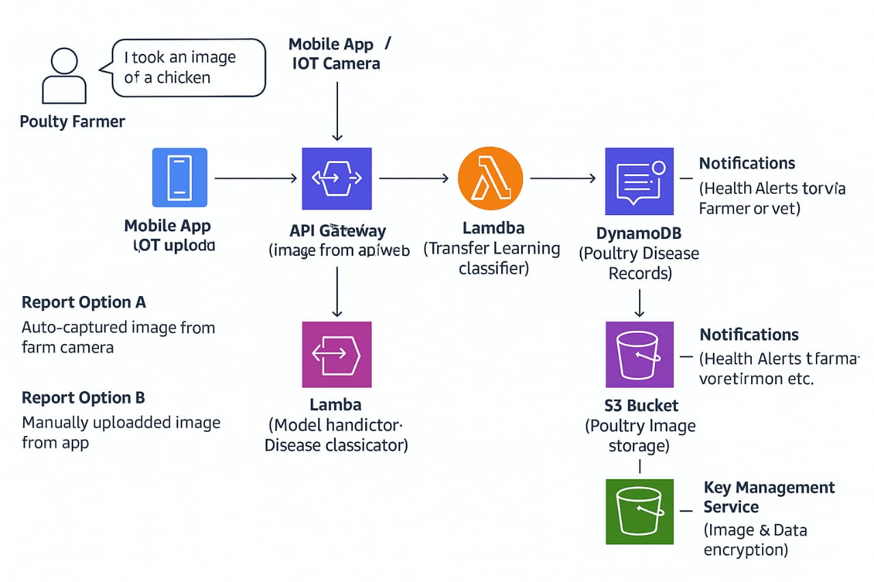

*Architecture and data flow of the poultry disease detection*

**Reference:** [**https://aws.amazon.com/blogs/industries/voice-applications-in-clinical-research-powered-by-ai-on-aws-part-1-architecture-and-design-considerations/**](https://aws.amazon.com/blogs/industries/voice-applications-in-clinical-research-powered-by-ai-on-aws-part-1-architecture-and-design-considerations/)